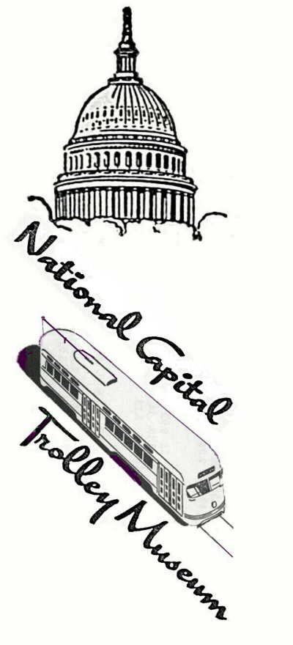
National Capital Historical Museum of Transportation, Inc.
1313 Bonifant Road,Colesville, Maryland 20905-5955

Telephone 301-384-6352
www.dctrolley.org

For Immediate Release
Media Contact Ken Rucker 301-384-6352 ext 1
National Capital Trolley Museum Hosts Holly TrolleyFest
Colesville, Maryland
November 3, 2017

The National Capital Trolley Museum hosts Holly TrolleyFest on Saturdays and Sundays from December 2nd to 23rd from Noon to 5 p.m.

Joanie Pinson, Museum Director of Education, explains, “Holly TrolleyFest features Santa aboard street car rides and toy trains in Santa’s Garden. Santa boards each street car trip and visits with children during their ride through Northwest Branch Park. Visitors may enjoy Santa’s Garden in the Museum’s auditorium, tour Street Car Hall with a docent, learn about the role of street cars in developing communities, and see the antics of Harold Lloyd in silent film comedies featuring street cars.”

The National Capital Trolley Museum is closed Christmas Eve and Day as well as New Year’s Eve and Day. The Museum opens on winter weekends beginning Saturday, January 6, 2018 at 1313 Bonifant Road, Colesville, Maryland. For further information please visit www.dctrolley.org or call 301-384-6088.

# # #

__________________________________________________________________
Preserving and interpreting the history of electric street and interurban railways for the Nation’s Capital

